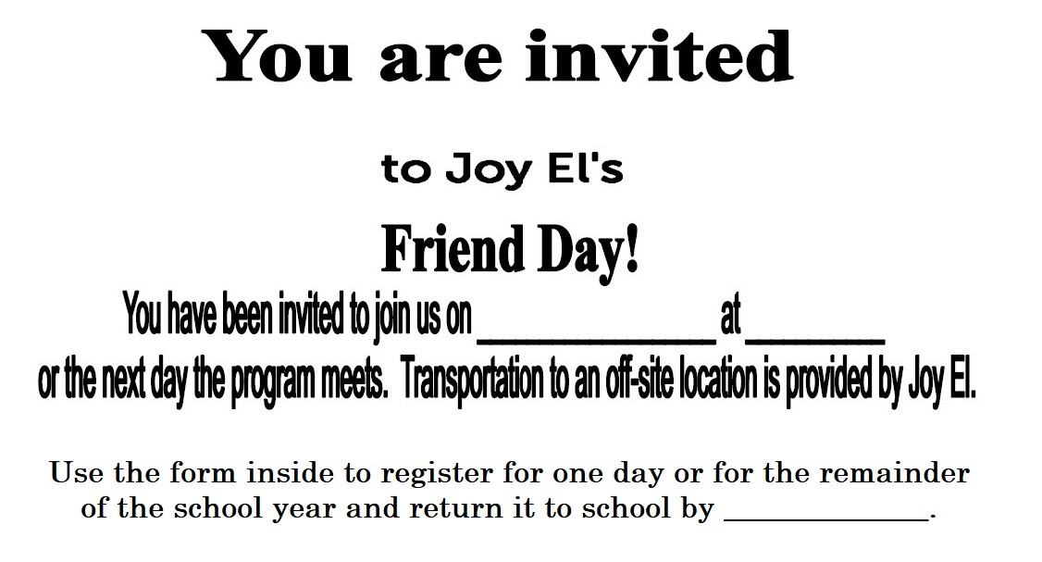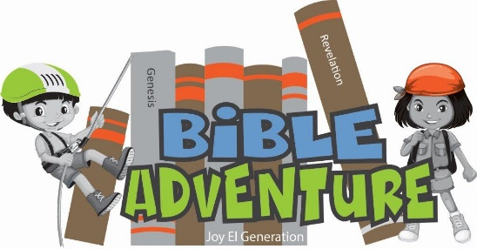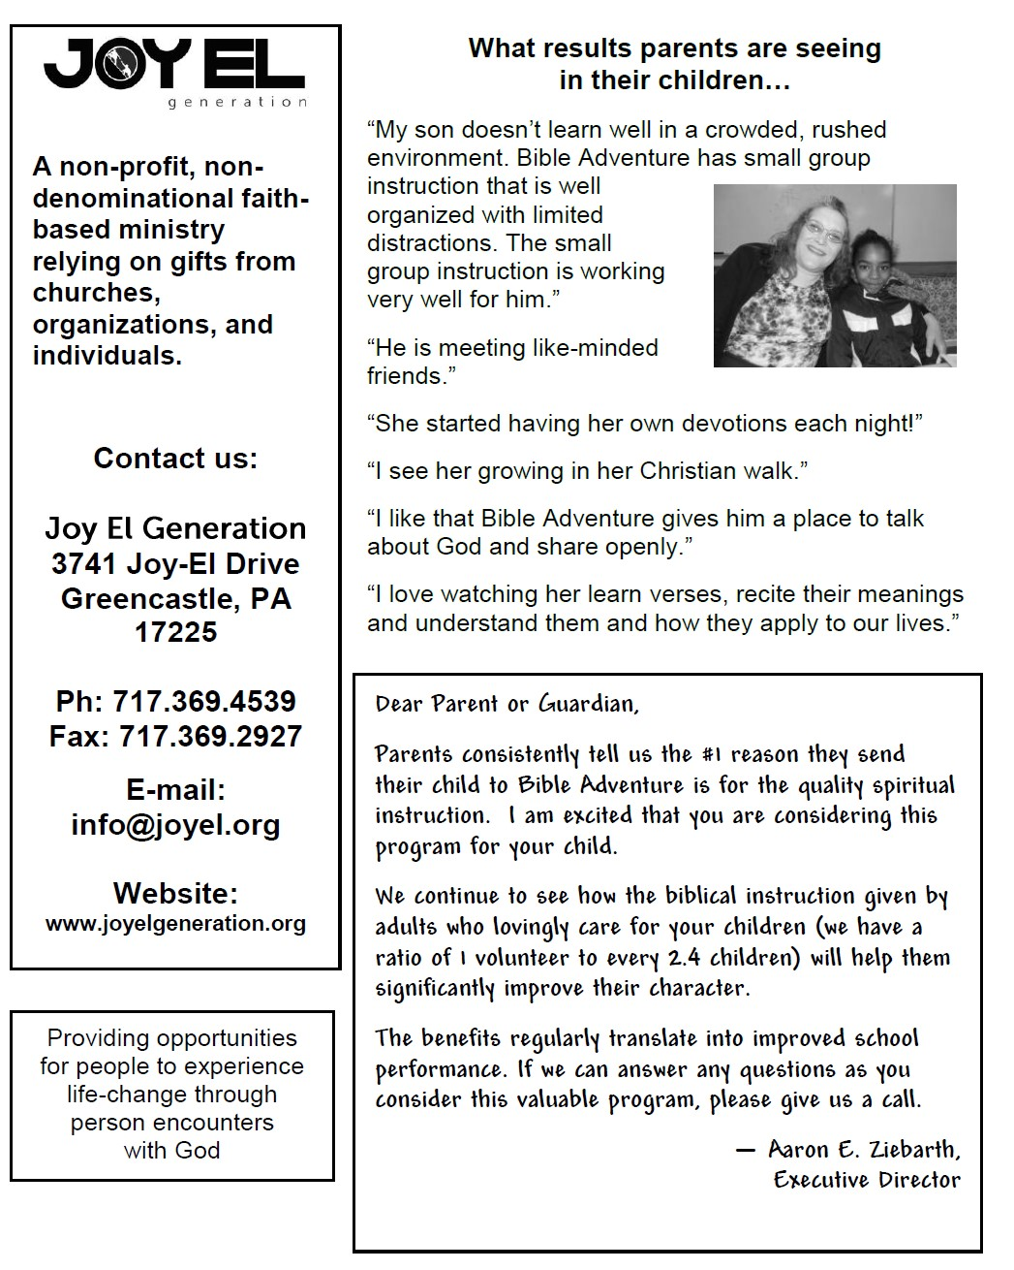

**to Joy El’s Bible Adventure**

**Friend Day!**

**You have been invited to join us on ____________________**

or the next day the program meets.

Transportation to an off-site location is provided by Joy El.

**Use the form inside to register for one day or for the remainder of the school year and return it to school.**

**Bible Adventure School Coordinator:**

