I want to invite your student to join us for a trip to the Museum of the Bible in Washington D.C.! This will be a day trip of engaging with this highly interactive museum and other students!

Here is an opportunity they don’t want to miss!
- A day trip with friends from the 4.12 Program
- Gain greater understanding of our Biblical Worldview
- Enjoy small group times

I strongly recommend that they attend this trip because it is a great opportunity to dig deeper into the worldview material that they study during their years in the program! Additionally, this will be a great opportunity to connect with other students.

See the below registration form for more details. Please email, scan, or mail the below form to rachel@joyel.org.

Blessings,

Rachel Shively
Director of 4.12 LTP

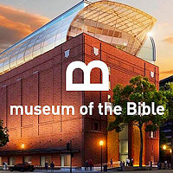  Questions: Contact Olivia at olivia@joyel.org or call 717-369-4539  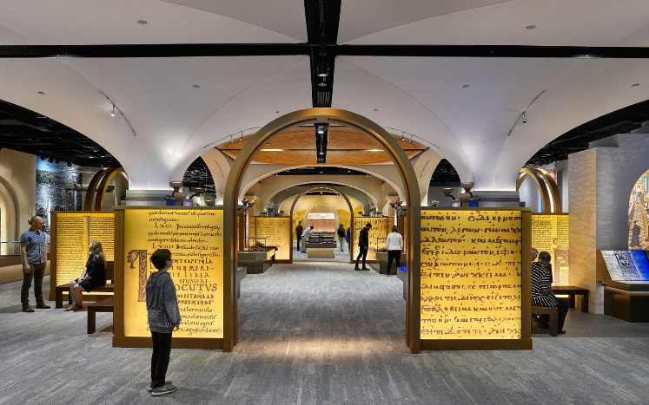  Additional Personal Monies: |  | Who?  All current 4.12 students!  When is it?  February 18th from 6:45 am – 8:15 pm (estimated)  Trip Cost (payable to Joy El)? $54 (non-refundable full payment due to reserve spot)  The payment deadline to reserve your spot is January 27th  Includes:  Lunch (at museum), dinner (Chick-fil-a), transportation, and museum registration with Washington Revelations ride  Arrival / Departure?  6:45 am Arrive at Joy El  7:00 am Load bus, pray and brief for day  8:00 pm Approximate return to Joy El. We will post updated time on 4.12 FB group by 7pm.  *(10-15 mins of clean up after arrival)  8:15 pm Pick up at Joy El
- $ for the store at the museum, 10% discount off 1 item! (if desired)

Registration Form

Student Name: ____________________________________

Level: 1 2 3 4 5

Age: ________

Address: __________________________________ State: Zip: __________

Phone Number:____________________________

Payment:
Cash______ Check:______ Credit Card______

Name on Card:______________________________________________
Card number:_______________________________________________

Security Code:___________ Exp Date:________

In signing this form, I, as a parent/guardian of this student, hereby fully waive, release and discharge my child to Joy El Generation for this trip. I further indemnify and hold harmless Joy El Camps and Retreats from any claims arising out of injury or harm my child may cause or suffer during the course of this trip.

Parent Signature:_______________________________________ Date:______________

