Series A Unit 5 Lesson 1
Jairus’ Daughter is Healed

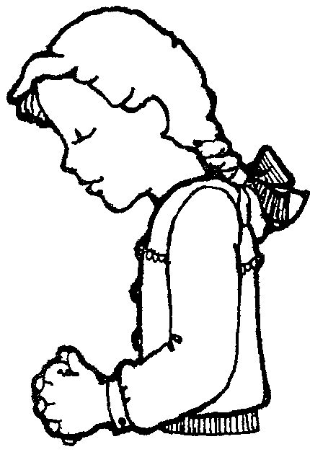
I Peter 5:7 says, “Cast all your anxiety on Him because He cares for you.” Other words for “anxiety” would be cares, needs, problems and concerns. Jesus wants us to bring all of these to Him in prayer.

Write a prayer to Jesus. Give your anxiety to Him because He cares for you.
Dear Jesus,

Thank You for hearing my prayer. Today I want to tell You about____________________________

______________________________________

______________________________________

______________________________________

______________________________________

Jesus I love You and I am glad You loved me enough to die on the cross for my sins.

___________________
Your name



Think

Series A Unit 5 Lesson 2
Jesus Feeds 5,000
Use this telephone keypad to complete
the verse below. First dial the numbers, then dial the letter in that square. For example: 71 is number 7 and the first letter in that square is “P”.
1 | ABC  2 | DEF  3
GHI  4 | JKL  5 | MNO  6
PRS  7 | TUV  8 | WXY  9
* | 0 | #

RESTORATION is our 4 Chapter focus today. We can join God in helping others learn about Him.

__ __ __ __ __ __ __ __ __ __ __ __
73 42 21 72 32 91 43 81 42 81 42 32

__ __ __ __ __ __ __ __ __ __ __ __ __ __
53 63 72 31 73 71 32 63 71 53 32 91 42 63

__ __ __ __ __ __ __ __ __.
21 72 32 43 62 62 32 32 31

__ __ __ __ __ __ __ __
71 72 21 23 81 43 23 32

__ __ __ __ __ __ __ __ __ __ __. (Romans 12:13)
42 63 73 71 43 81 21 53 43 81 93

Today I will tell _________________ about Jesus.
Name of a classmate



Series A Unit 5 Lesson 3
Good Samaritan
Complete the words below by matching the number with the letter found in the same box.

O  1 | H  2 | B  3 | S  4 | V  5
L  6 | I  7 | E  8 | A  9 | D  10
U  11 | N  12 | Y  13 | T  14 | R  15

____ ________________ ____ ______
3 8 10 8 5 1 14 8 10 14 1 1 12 8

Got it!

________________ ____ _______.
9 12 1 14 2 8 15 7 12 6 1 5 8

___________ ______ ________________
2 1 12 1 15 1 12 8 9 12 1 14 2 8 15

_________ ______________________. (Romans 12:10)
9 3 1 5 8 13 1 11 15 4 8 6 5 8 4

Make a decision today to treat others the way you want
to be treated.

4 Chapter Gospel

How did it all begin?
Where did I come from?
Genesis 1:1,31
Genesis 1:27; 2:7

What went wrong?
Have you experienced hurt or pain?
Genesis 3:6-10
Romans 3:23
Romans 6:23

Can anything be done?
How does Jesus fix this broken world?
Romans 5:8
Luke 19:10
II Corinthians 5:17-21

What will the future hold?
Revelation 21:1-5
How can I join God now in His work?
Mark 16:15

