Series A Unit 4 Lesson 1
The Boy Jesus at the Temple

Jesus wants each of us to follow Him. Find your way through the maze
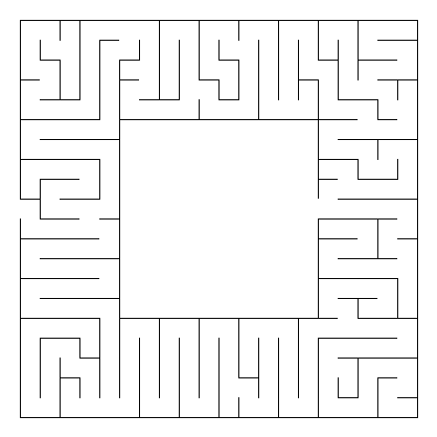


Follow Jesus
Start here

John 1:1- In the beginning was the Word, and the Word was with God, and the Word was God.

Who is “the Word” in the verse above? ____________

Are you following Him? ___________

Series A Unit 4 Lesson 2
Jesus Calls the First Disciples

He who __ __ __ __ __ you is __ __ __ __ __ __ __ __,
4 7 2 2 6 3 7 1 5 9 3 11 2

__ __ __ He __ __ __ __ do __ __ I Thessalonians 5:24
7 10 8 12 1 2 2 1 5

I  1 | L  2 | F  3 | C  4 | T  5 | S  6 | A  7 | D  8 | H  9 | N  10 | U  11 | W  12


Jesus picked special helpers called disciples to follow Him. He wanted them to stop catching fish and fish for people. He wanted them to tell people about GOD’S LOVE.

Are you telling your friends about God’s Love?

Series C Unit 4 Lesson 3
The Wise and Foolish Builders

Search and find the bold words from your verse in the puzzle.

W | E | V | L | G | L | Y | E | P | E
R | O | C | K | I | O | M | R | N | P
J | U | R | K | T | N | D | O | M | R
C | K | E | D | E | I | Y | F | A | A
N | N | I | S | S | R | G | E | T | C
U | A | U | X | E | K | T | R | T | T
R | O | M | V | C | H | L | E | H | I
H | H | E | A | R | S | I | H | E | C
P | U | S | Z | G | M | U | T | W | E
C | E | S | I | W | W | B | N | I | D

Therefore everyone who hears these words of mine and puts them into practice is like a wise man who built his house on the rock. Matthew 7:24
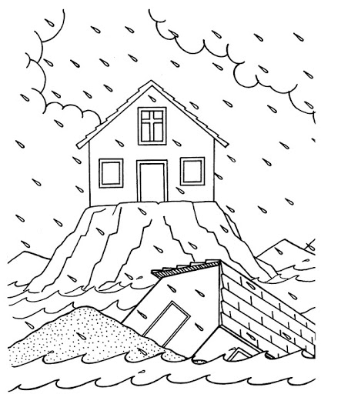

Is your life (house) on the rock?

4 Chapter Gospel Review

How did it all begin?
Genesis 1:1,31

Where did I come from?
Genesis 1:27; 2:7

What went wrong?
Genesis 3:6-10

Have you experienced hurt or pain?
Romans 3:23
Romans 6:23

Can anything be done?
How does Jesus fix this broken world?
Romans 5:8
Luke 19:10
II Corinthians 5:17-21

What will the future hold?
Revelation 21:1-5

How can I join God now in His work?
Mark 16:15

