

A non-profit, non-denominational faith-based ministry relying on gifts from churches, organizations, and individuals.

Contact us:

Joy El Generation
3741 Joy-El Drive
Greencastle, PA 17225

Ph: 717.369.4539
Fax: 717.369.2927

E-mail: info@joyel.org

Website:
www.joyelgeneration.org

Bible Adventure
is operated by

Joy El Generation
3741 Joy El Drive
Greencastle, PA 17225
717-369-4539
www.joyelgeneration.org

Questions? Call

What results parents are seeing
in their children…
“My son doesn’t learn well in a crowded, rushed environment. Bible Adventure has small group instruction that is well organized with limited distractions. The small group instruction is working very well for him.”
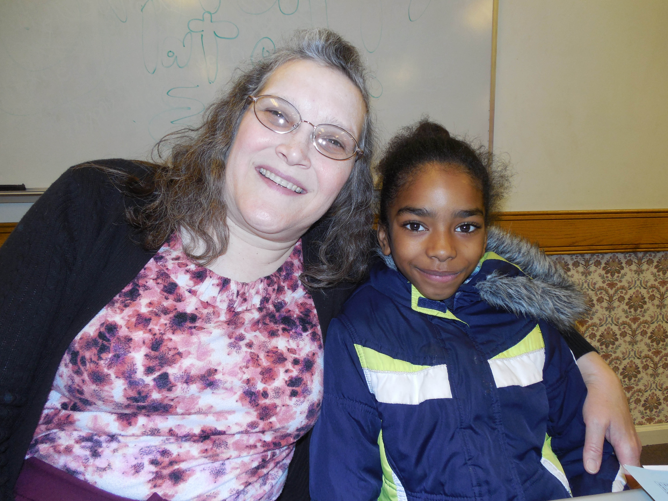
“He is meeting like-minded friends.”
“She started having her own devotions each night!”
“I see her growing in her Christian walk.”
“I like that Bible Adventure gives him a place to talk about God and share openly.”
“I love watching her learn verses, recite their meanings and understand them and how they apply to our lives.”
Dear Parent or Guardian,
Parents consistently tell us the #1 reason they send their child to Bible Adventure is for the quality spiritual instruction. I am excited that you are considering this program for your child.
We continue to see how the biblical instruction given by adults who lovingly care for your children (we have a ratio of 1 volunteer to every 2.4 children) will help them significantly improve their character.
The benefits regularly translate into improved school performance. If we can answer any questions as you consider this valuable program, please give us a call.
— Aaron E. Ziebarth,
Executive Director

Providing opportunities for people to experience life-change through person encounters
with God

Your school coordinator is:

Contact this person for information about
Bible Adventure at your school.

Bible Adventure has academic benefits
for your children!
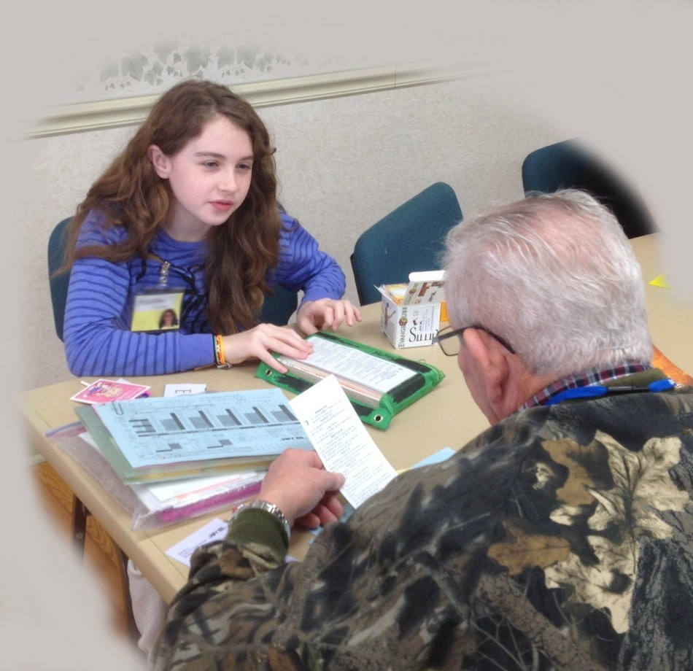
The National Council on Crime and Delinquency did a study* on Released Time classes that found the following:

1. “A comparative review of all 4th and 5th graders involved in this program perform better than their classmates as a whole in almost every category.”

2. “Released Time students improved after one year in three categories of literacy skills: comprehension, spelling, and vocabulary.”

3. “The program also provides youth with strong adult mentorship and bonding, and reinforces positive moral and character development in an environment where teachers and administrators struggle with unruly students.”

* Summary of Findings: Released Time Bible Education. A program evaluation conducted by The National Council on Crime and Delinquency. http://www.nccdglobal.org/sites/default/files/publication_pdf/bible-education.pdf.

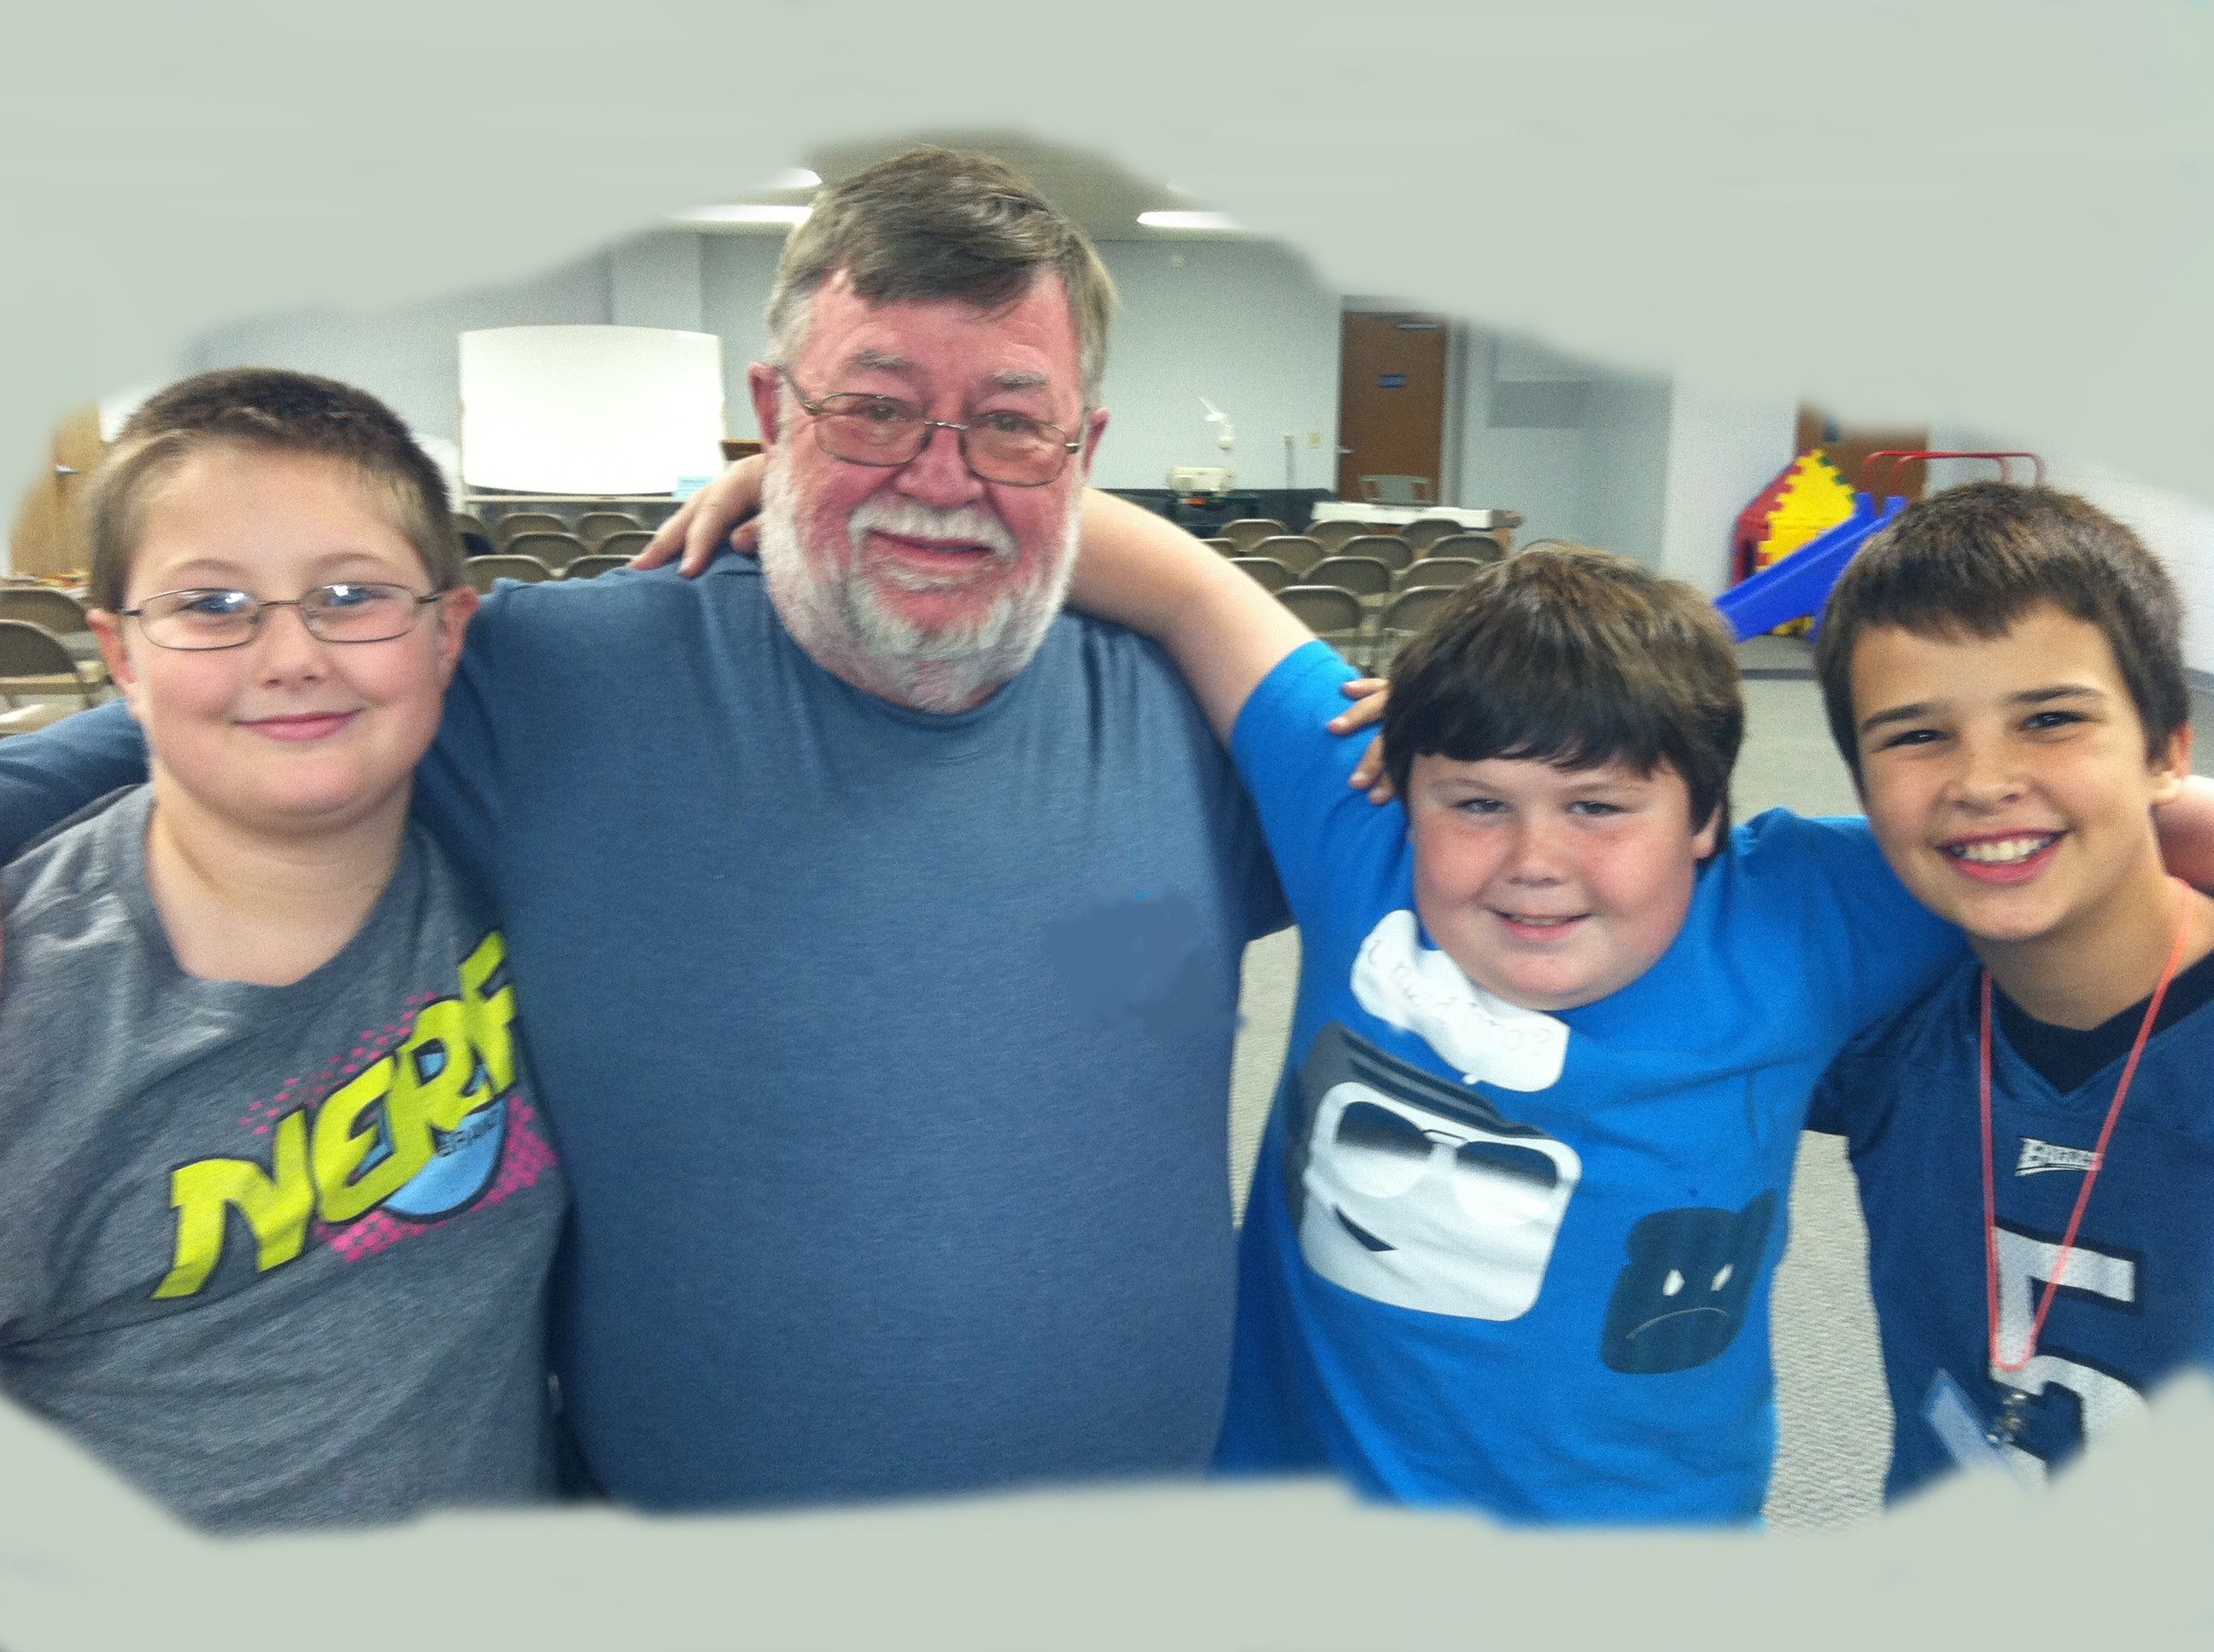
Additionally, Bible Adventure provides…
- A safe environment for learning.
- A place to belong, where children are valued and listened to.
- A place where spiritual questions can be safely asked and addressed.
- An opportunity to memorize scripture and earn awards that lead to discounts toward summer camp. A total of 300 points earns a week of FREE camp at Joy El Camps & Retreats!

The FAQS about Bible Adventure
A legal, state-approved program that allows public school students to be dismissed from school for biblical education.
Not affiliated in any way with or sponsored by the school district.
Sponsored by Joy El Generation for students beginning in 3rd grade.
Held off school property during school and children are transported or walked by
Joy El Generation volunteers.

Free to participants.
Parental permission required. Students are enrolled on a first-come first-served basis. Children who register must attend weekly unless a parent withdraws the student in writing.
School work missed while attending Bible Adventure can be made up.

Bible Adventure friend who invited me _______________________________________
Please check one of the following boxes. I give permission for my child to attend:
Invite a Friend Day (1day) OR Remainder of school year

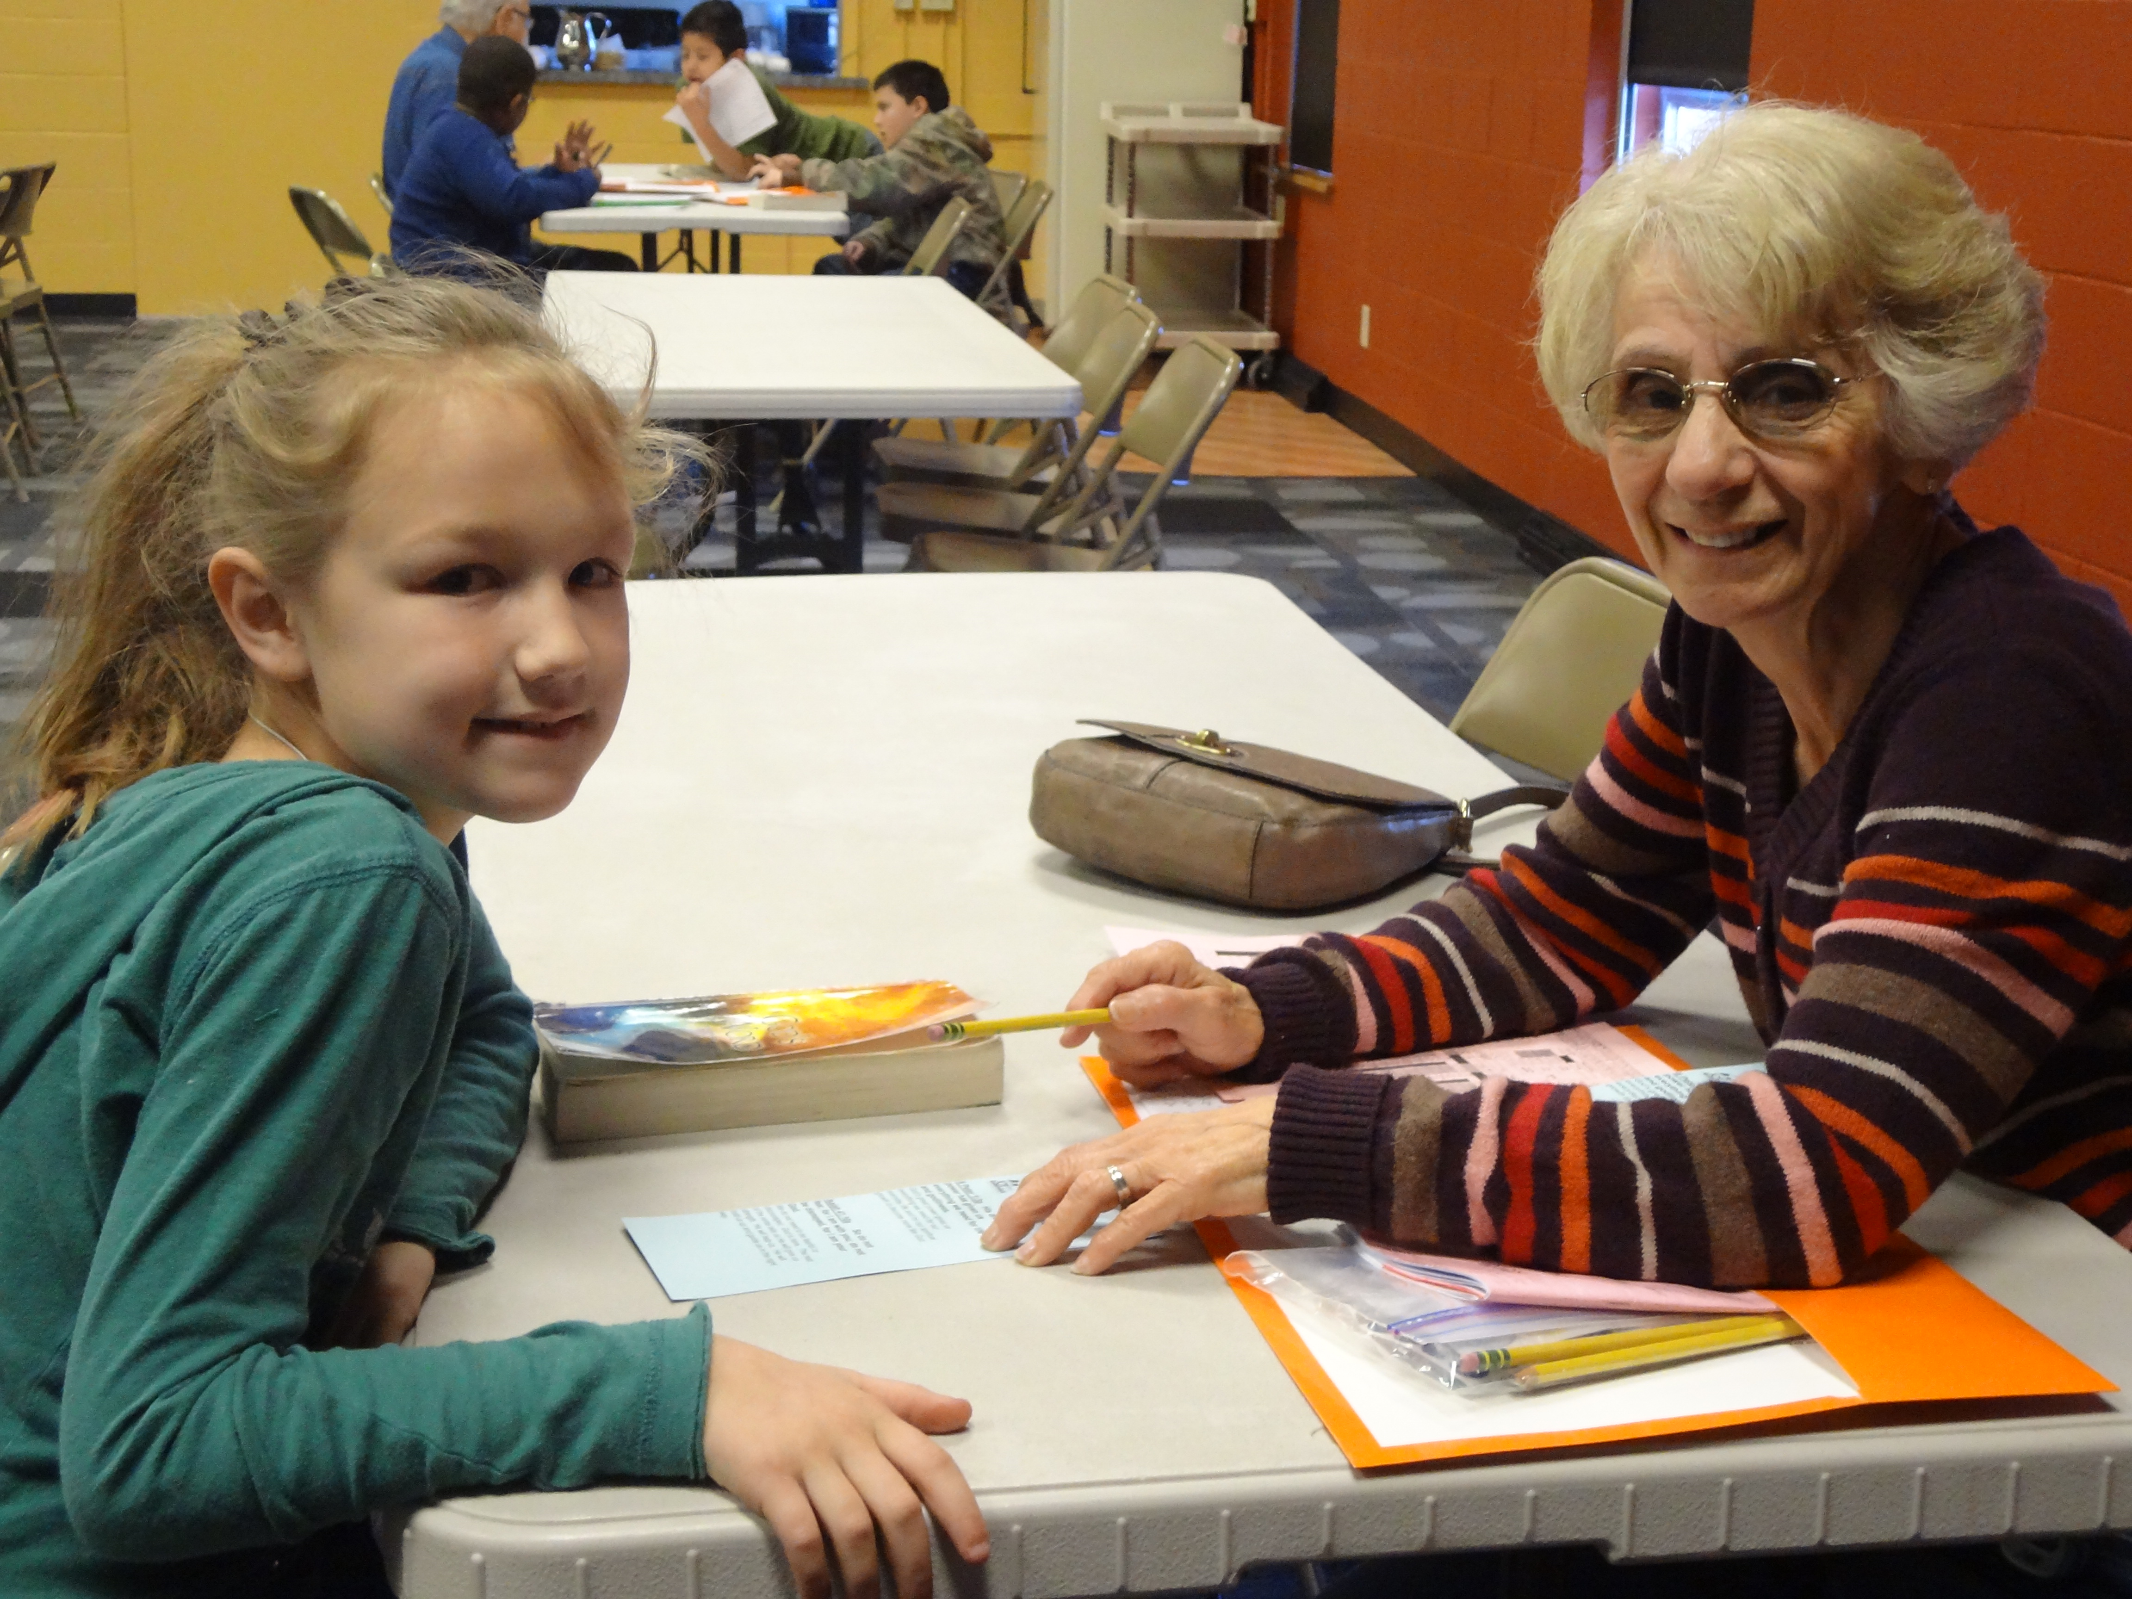

Last Name | First Name |  | Gender (Circle one)  Male Female
Address |  | City / State
Zip Code | Home Phone #  ( ) |  | Birth Date
School |  | Grade | Homeroom /Teacher
Parent(s) or Guardian(s) |  | Parent Email
Parent Work Phone  ( ) |  | Parent Cell Phone  ( )
Home Church (if any) |  | Church Phone  ( ) | Church Email
Emergency Contact Name |  | Emergency Contact Phone  ( )
Doctor |  | Doctor Phone  ( )
Health Insurance Co. |  | Health Insurance Policy #
List medications your child is allergic to, health problems, and special behavioral or learning needs.

1. Would you be willing to serve as a Bible Adventure volunteer? Yes __________ No ___________
2. Has your child attended Bible Adventure before? Yes __________ No__________
If yes, in what school and what grade? ___________________________________
3. I give permission for my child to participate in Bible Adventure______
4. I understand my child will be walked or transported (van, bus, or personal vehicle) to and from the place of instruction by the Bible Adventure volunteer staff.
5. Bible Adventure volunteer staff will serve in loco parentis for me to attest to my child’s attendance at the religious sessions.
6. I give permission for Joy El to use photos that include my child in print or electronic media for publicity purposes.
7. Joy El Generation will in no way be responsible for medical treatment or liability resulting from physical conditions existing prior to my child attending Bible Adventure.
8. By providing an email address, I am granting Joy El permission to email news and information about
Joy El programs to the address(es) provided.
9. I give permission to the Bible Adventure volunteer staff to act on my behalf in my child’s best interest in the event of an accident or emergency. I give permission to the hospital and/or doctor to treat or operate on my child.
10. I give Joy El permission to release insurance information to medical or hospital personnel in the event that my child should need medical attention.

________________________________________________ _______________
Parent Signature (My signature implies consent for all above statements.) Date

